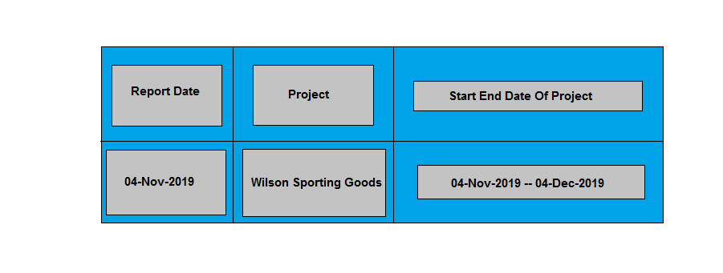  
**Project Summary Aptech/North Nazimabad**

E-Project Review Document

Problem Statement:

WILSON SPORTING GOODS is selling various types of Sports Goods. The company advertises by distributing the pamphlets, advertising on television and so on. Due to rapid development in internet field, the company decides to launch a website where people will get all the information about the various products available with them easily.

Project Progress:

Pages

Online Shop

Home Page

CATEGORIES

HOME PAGE:

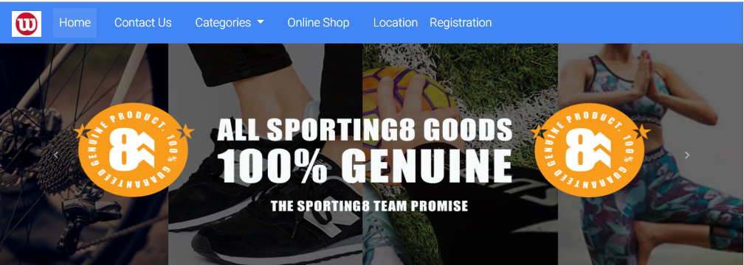

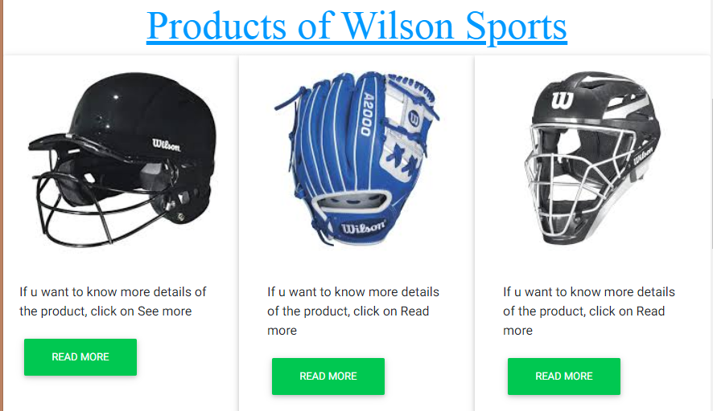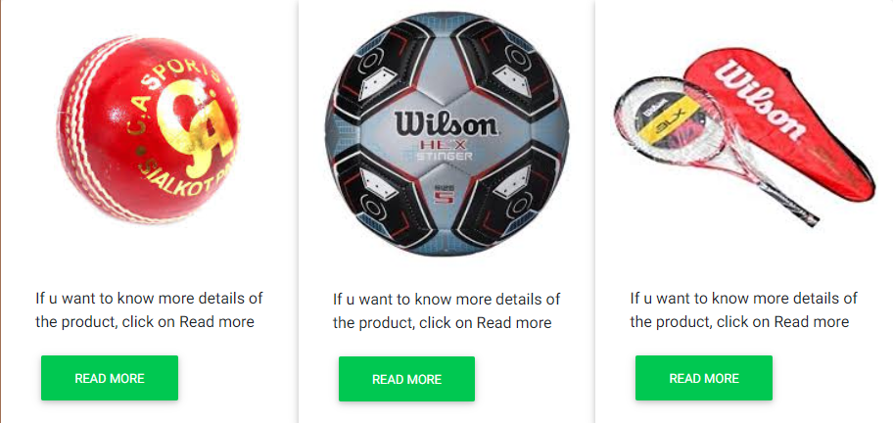

**READMORE & READLESS FUNCTION:**

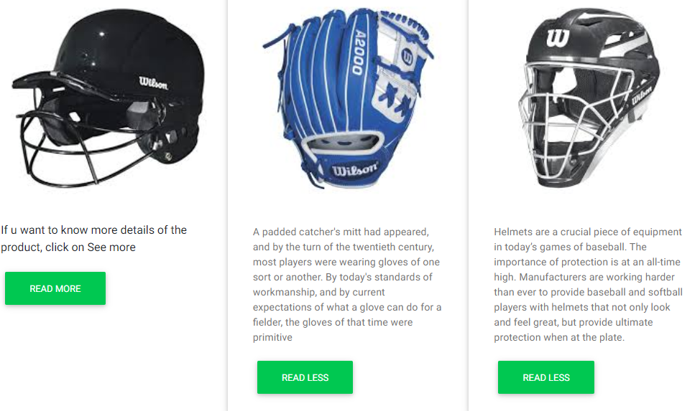

ONLINE SHOP

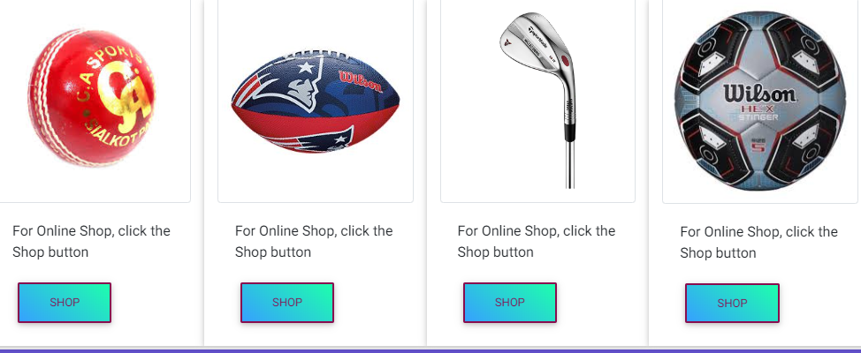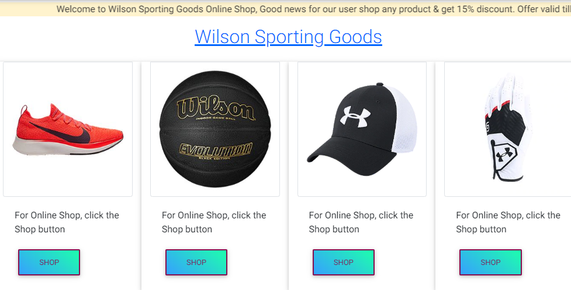

**CATEGORIES SECTION:**

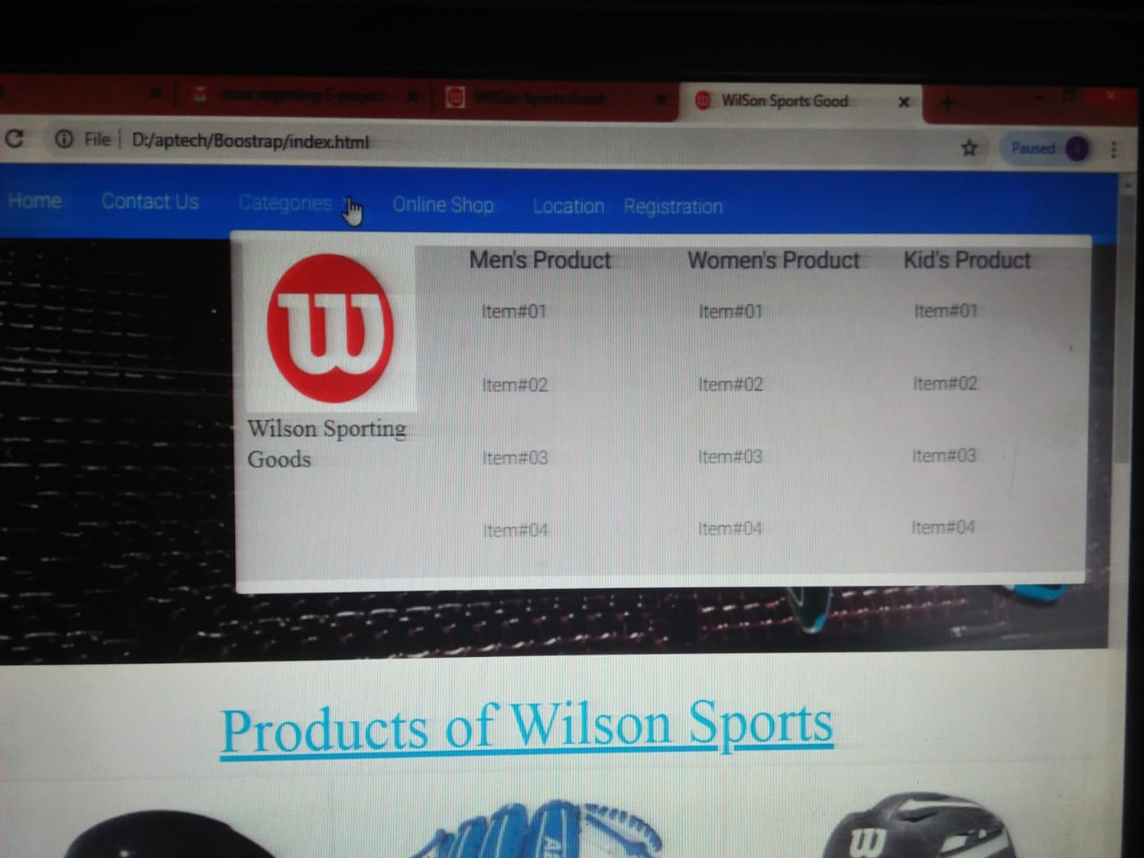

GROUP MEMBER & WORKING:

|  |  |  |
| --- | --- | --- |
| STUDENT NAME | ENROLLMENT # | WORKING |
| **Wajahat Mansoori** | **Student1214179** | Home page, Carousel, Products Intro with Readmore & Readless Function, Footer, Online shop Page, List of Different Products, & by clicking on any products the sub list of that product will open. For Example If user Click on Sports Shoes then all the products related to Sports shoes will show to the user, Add to Cart Function. |
| **Yaseen Saleem** | **Student1214181** | - |
| **Anas Ansari** | **Student1214182** | - |
| **Ubaika** | **Student1214173** | Design category Mega Nav Bar in which different categories of sports Products W.R.T genders are available. For Example if user want to search Men’s product he can easily access by clicking the products mentioned in the list. |